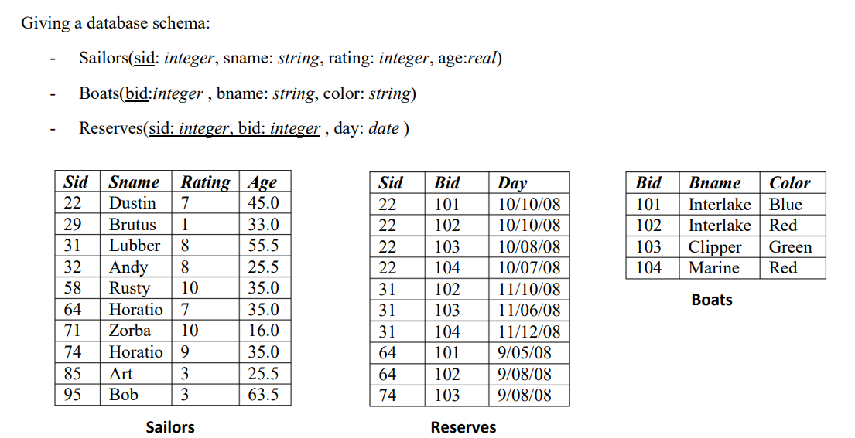

1. Find the names of sailors who have reserved boat 103

πSname (σBid = 103 (sailors ⋈sailors.Sid=reserves.Sid reserves))

1. Find the names of sailors who have reserved a red boat

πSname (σColor = “red” (sailors ⋈ reserves ⋈ boats))

1. Find the colors of boat reserved by Lubber

πColor (σ Sname = “Lubber” (sailors ⋈ reserves ⋈ boats))

1. Find the names of sailors who have reserved at least one boat

πSname(σBid >=1 (sailors ⋈ reserves))

1. Find the names of sailors who have reserved a red or green boat

πSname (σColor = “red” or color = “green” (sailors ⋈ reserves ⋈ boats))

1. Find the names of sailors who have reserved a red and a green boat

πSname (σColor = “red” and color = “green” (sailors ⋈ reserves ⋈ boats))

1. Find the sids of sailors with age over 20 who have not reserved a red boat

πSid (σ age > 20 ^ σ color (Sailors ⋈ resevers ⋈ Boats) - πsid

( σ age > 20 ^ σ color = “red” (Sailors ⋈ resevers ⋈ Boats)

1. Find the names of sailors who have reserved all boats

πSname (ΣBid=101 and Bid=102 and Bid=103 and Bid=104 (sailors ⋈ reserves ⋈ boats))

1. Find the names of sailors who have reserved all boats called Interlake

πSname (ΣBname= “Interlake”(sailors ⋈ reserves ⋈ boats))

10.Find the names of sailors who have reserved at least two boats

πSname(σBid >=2 (sailors ⋈ reserves))